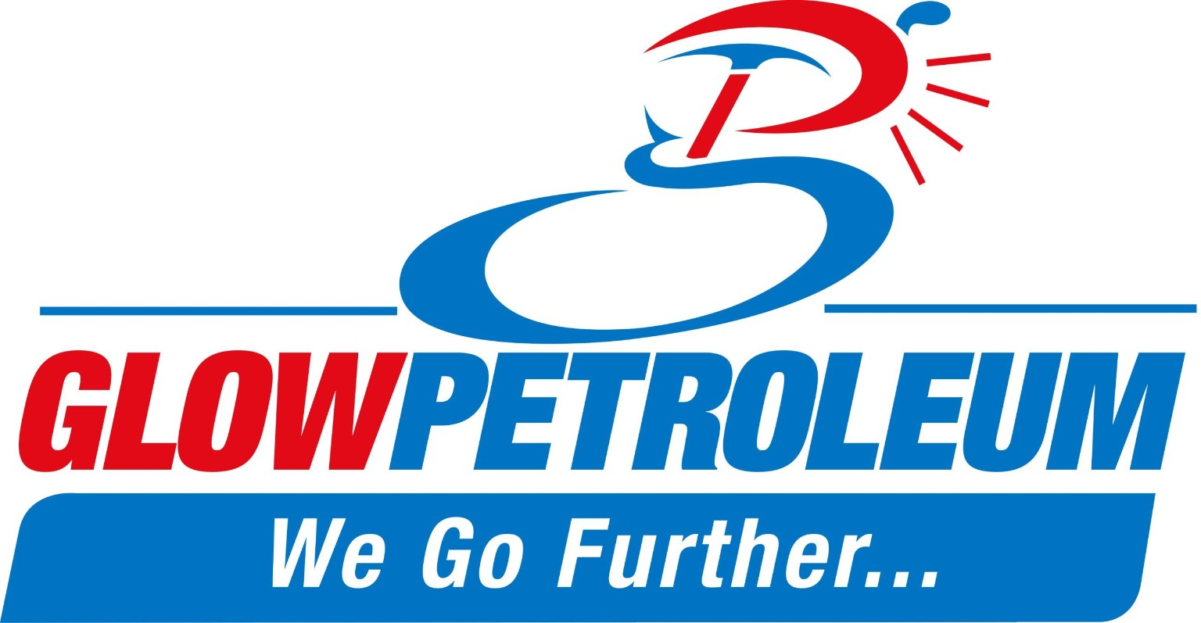

Safety, Health & Environment (SHE) Policy
At Glow Petroleum, safety, health, and environmental stewardship are fundamental to the way we conduct our business. We are committed to providing quality petroleum products while protecting our employees, customers, contractors, communities, and the environment.
As a responsible energy company, we strive to prevent injury, illness, environmental harm, and pollution by integrating Safety, Health, and Environment (SHE) principles into all our operations.
Our Commitments
We are committed to:
Compliance
Comply with all applicable safety, health, environmental laws, regulations, standards, and industry best practices.
Risk Management
Identify, assess, and control risks associated with our operations through effective hazard identification, risk assessments, and environmental impact evaluations.
Pollution Prevention
Prevent pollution, minimize waste, conserve natural resources, and promote responsible environmental management practices.
Sustainable Operations
Adopt sustainable technologies, processes, and management systems that enhance operational efficiency while reducing environmental impacts and supporting climate resilience.
Continuous Improvement
Maintain and continually improve our SHE Management System by setting measurable objectives, monitoring performance, and implementing corrective actions where necessary.
Biodiversity and Environmental Protection
Support the protection of biodiversity, ecosystems, and natural resources through responsible business practices and environmental stewardship.
Stakeholder Engagement
Engage employees, customers, suppliers, contractors, regulators, and communities in promoting a positive and proactive SHE culture.
Training and Awareness
Provide employees and contractors with the necessary training, resources, and knowledge to perform their duties safely and responsibly.
Zero Harm Culture
Promote a culture of safety aimed at achieving zero harm to people, property, and the environment.
Accountability
Ensure that all employees, contractors, and business partners understand and fulfill their SHE responsibilities.
Our Responsibility
The successful implementation of this policy requires the commitment and participation of all employees, contractors, and stakeholders. Management is responsible for providing leadership, resources, and oversight to ensure that SHE objectives are achieved and maintained.
Glow Petroleum reviews this policy regularly to ensure its continued relevance, effectiveness, and alignment with business objectives and stakeholder expectations.
Approved by:
N. Chinhara
Managing Director
Last Reviewed: January 2024

